Final Hands-on Exam
CIT-1121
Spring 2024
In this lab you will design a VLSM addressing scheme given a network address and host requirements.
You will configure addressing on routers, switches, and network hosts. Section 1 (20 Points)
- Design a VLSM IP addressing scheme given requirements.
10.10.10.0/24
    - Sales Department 110 hosts
    - Marketing Department 52 hosts
    - HR department 23 hosts
Departments | Network ID | Subnet  Mask | First usable  IP address | Last usable  IP address | Broadcast address | Default gateway
Sales | 10.10.10.0 | 255.255.255.128 (/25) | 10.10.10.1 | 10.10.10.126 | 10.10.10.127 | 10.10.10.126
Marketing | 10.10.10.128 | 255.255.255.192 (/26) | 10.10.10.129 | 10.10.10.190 | 10.10.10.191 | 10.10.10.190
HR | 10.10.10.192 | 255.255.255.244 (/27) | 10.10.10.193 | 10.10.10.222 | 10.10.10.223 | 10.10.10.222

- Configure addressing on network devices and hosts.

Section 2 (20 Points)
Basic Device Configuration on the Router and the Switches:
- Configure Host names
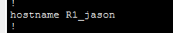
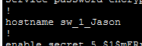
- Configure a Banner Message
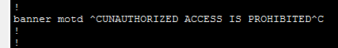
- Configure a console password, and allow login
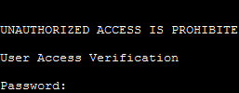
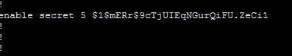
- Configure VTY password, and allow login
- 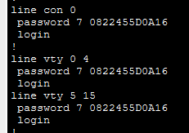
- 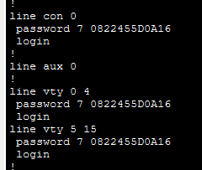
- Configure all passwords to be encrypted
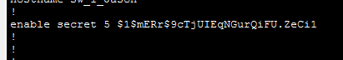

Section 3 (20 Points)
Router configuration:
- Assign the last usable IP address from each subnet to the interface of your router connected to the subnet and use it as your default gateway for all the devices connected to the subnet.
Switch configuration:
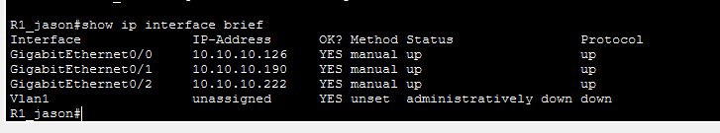

- Assign the second usable IP address from your VLSM calculations to the VLAN 1 in the switch in each department
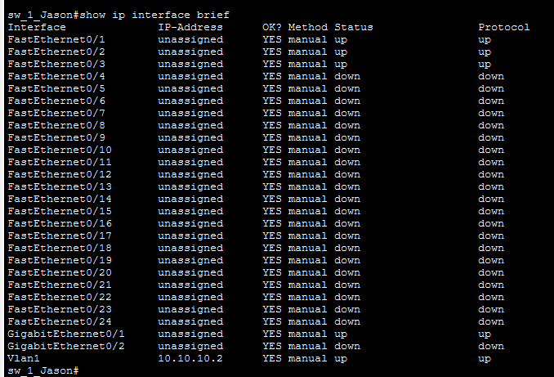

Section 4 (20 Points)
Remote Access:
- Configure SSH access on the Marketing Department switch (SW-sales)

Section 5 (20 Points)
Verification of connectivity:
- Verify that each PC can ping the gateway in their own subnet
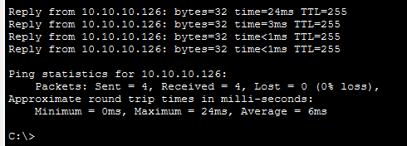
- Verify SSH connectivity for the Sales Department Switch (SW-sales)
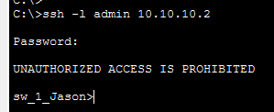
- Verify ARP entries on the PCs
